
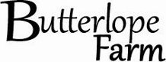
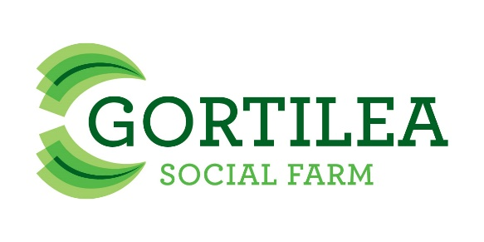

SoFarm Programme and Learning Plan
Introduction
SoFarm is a project led by Rural Area Partnership in Derry (RAPID) Ltd in partnership with Gortilea and Butterlope Social Farms. It is supported by the Northern Ireland European Social Fund Programme 2014-2020 through the Department for Employment and Learning and the Health and Social Care Board.
The focus of the project is to use Social Farming to enable people with disabilities to achieve their aspirations and play a fuller role in society by undertaking training on the Social Farms and through RAPID which is a LANTRA training centre. The activities offered by this project will be ‘person centred’ and will be tailored to individual needs. Social Farming has been shown to offer people with a disability the opportunity to engage and contribute by choice in farming, training and social activities. This is offered through the medium of ordinary farms acting in partnership with services and those who avail of supports. It provides disadvantaged groups of people with an opportunity for inclusion, to increase their self esteem and to improve health and well-being.
The SoFarm programme will provide:
- An Innovative approach to programme delivery
This programme will engage those with an interest in farming and outdoor activities and will be flexible and participant led. Action Plans will be led by the participant with the Occupational Therapist providing support in a non formal environment.
- A Non Traditional Education Services
This project adopts a non traditional education approach which is “person centred” with flexibility for the participant at the core.

- A Mentor Approach
The evidence from the Social Farming pilot project identified the Mentoring by the Farm Manager as one of the main elements of success in relation to the development of not only farming skills but in increased motivation, self esteem and confidence.
- Training provision
Training provision will be person centred and will include LANTRA Level 1 in Health and Safety which will allow participants to engage in a very short course initially in order to achieve “quick wins” which will boost confidence and motivation.

Training and qualifications
RAPID is an approved provider for LANTRA Awards. Lantra Awards are a nationally recognised Awarding Organisation (AO) with almost 40 years specialising in training and qualifications primarily for the environment and land-based sector.
They are approved by the Office of Qualifications and Examinations Regulation (Ofqual) who also regulate on behalf of Council for the Curriculum, Examinations and Assessment (CCEA) in Northern Ireland.
RAPID has chosen LANTRA Awards as they offer accredited courses and qualifications in the agricultural and land management sector. They also offer qualifications that are flexible in delivery and designed to accredit the practical work and learning that individuals are achieving by participating on daily activities on a Social Farm.
All learner activity is internally assessed and verified by RAPID followed by external verification by LANTRA. Assessment is carried out by the tutor who works with each learner and the Farm Manager to provide evidence to fulfil the learning outcome requirements of each unit.
The participants will undertake units in the LANTRA Land based activities qualification. These units are designed for learners who wish to develop their knowledge and skills in the land-based sector enabling them to work safely, effectively and efficiently in the workplace. It will suit a number of different needs, including those learners looking to progress into work, further learning or an apprenticeship. There is no specific entry requirement.

LANTRA Land Based Activities
Each learning session is 3.5 hours
LANTRA Awards Level 1 Units in Land-based Activities
Unit | Credits | Guided On Farm Learning Hours
Health & Safety | 3 | 23 hours – 7 sessions
Farm animal health | 4 | 40 hours – 12 sessions
Assist with preparing and maintaining livestock accommodation | 2 | 18 hours – 6 sessions
Assist with preparation and the monitoring of livestock outdoors | 2 | 18 hours – 6 sessions
Farm conservation | 3 | 30 hours – 9 sessions
Total |  | 129 hours – 40 sessions

Progression:
Each learner can progress to Level 2 in Land based activities on completion of the Level 1 units following completion of the ESF programme and can choose which units to complete.
Please note: Assessment is flexible and the training is designed to accredit the practical work and learning which is achieved as a result of participating in the Social Farming Activities.
Contact:
Clare Mc Monagle - Occupational Therapist
gortileasocialfarm@gmail.com




